The Effect of PDO on AO/NAO Relationship: A brief overview

Kazimir Nyzio,ª
ª University of Albany, Albany, New York
ATM 522: Climate Variability and Predictability

Dr. Oliver Timm
ABSTRACT
This study investigates the effect that the condition of the Pacific Decadal Oscillation (PDO) has on the relationship between the Arctic and North American oscillations (AO and NAO, respectively). The discussion on the merits the Arctic vs North American teleconnections as descriptors of variability is long and not yet fully conclusive. Therefore, the incorporation of longer time-frame effects is intended to provide a new perspective, both through its effect on the interaction of these modes, and to the question of the favorability of one over the other in the climate variability discussion. This is accomplished simple mean sea-level pressure correlation plots, covariance matrices over the arctic oscillation’s three significant centers of action, and a principal component analysis of this pressure field, all for each phase of the PDO. The correlation plots suggest an amplified anticorrelation between the Iceland and Aleutian low and high during the PDO+ compared to PDO-, validated by their corresponding values in the covariance matrices. Furthermore, the first principal components (AO) of the PDO+ condition described more variability than the alternative, with values in agreement with prior literature. Using said data, this literature had posited that the NAO is more descriptive of Northern Hemispheric variability than the annular AO. This would suggest that the PDO- regime is even less favorable for the case of the AO, furthering the argument for NAO’s role as the dominant Northern Hemisphere mode.

SIGNIFICANCE STATEMENT
The methods by which different global teleconnections interact are significant for an understanding of climate variability, climate dynamics, and climatic prediction. Therefore, the conceptual and quantitative weighting of various indices (in the case of a forecasting model) is ever relevant. In the case of this study, further emphasis may be put on the NAO for long-term climate predictions or for seasonal-to-season prediction during PDO- periods.
- Introduction
a. The Arctic Oscillation
The Arctic Oscillation (AO) as defined in Thompson and Wallace (1998) is considered a significant mode of variability in the Northern Hemisphere and dominant exemplar of the “Annular” mode, due to the symmetry of its zonal flow. It is derived from the leading equal orthogonal function (EOF) of the wintertime sea-level pressure field in the Northern Hemisphere and is commonly associated with strength of the Arctic Polar Vortex, a column of air formed in the polar night that spans the troposphere and stratosphere. The index of the AO is characterized by the anomaly in the arctic low, where a positive (negative) phase represents lower (greater) pressure, a greater (weaker) pressure gradient with the mid-latitudes, stronger (weaker) jet stream, and less (more) active Rossby Wave behavior in lower latitudes. In this formative study, its significance was evidenced by strong association with Eurasian surface temperature behavior, particularly in accounting for the trends experienced there during the decades preceding the study. Subsequent studies have supported the legitimacy of this mode through its behavior in comparison with the concurrently established Southern Hemisphere annular mode, whose phases diametrically oppose the AO (Thompson and Wallace 2000), and its coincident structural changes with eminent climate trends of the time (Thompson et al. 2000).
b. AO vs. NAO
Following this introduction, a period of debate has formed within the scientific community concerning the role the AO plays alongside the North Atlantic Oscillation (NAO) (Walker and Bliss, 1932) and other ‘sectoral’ paradigms such as the Pacific North American teleconnection (PNA) (Wallace and Gutzler 1981), which is yet to be resolved (Dai and Tan, 2017). Deser (2000) assessed the teleconnectivity of the mode and the amount that it represented and correlated trans-hemispheric patterns, notably the Pacific and Atlantic variability, utilizing covariances between action-centers in both basins. Furthering this, Ambaum et al. 2001 described in more depth the AO’s physical consistency, jet-stream behavioral modification, and covariance structures. Christiansen (2002) rotates EOF of 500 hPa geopotential height to claim that the AO is rather a difference between the PNA and NAO. Similarly, Itoh (2008) asserts that the patterns reflect the overlapping of both sectoral modes. Some even claim the two are entirely indistinguishable (Feldstein and Franzke, 2006). Finally, Gong and Nath (2018) noted the variability in performance of the AO to describe the Northern Hemisphere during different periods, where 1920-1959 and 1986-2010 demonstrated strong surface air temperature association and 1960-1985 demonstrated weak surface air temperature association. This is where the present study intends to contribute to this discussion.
c. Pacific Decadal Oscillation
The Pacific Decadal Oscillation (PDO) is one of the most significant low-frequency modes of variability in the Northern Hemisphere. With the advent of significantly sized datasets due to consistent satellite measurements of sea-surface temperatures (SST) in the latter half of the 20th century, the PDO was able to be identified by Mantua et al (1997) as a “recurring pattern of ocean-atmosphere climate variability centered over the midlatitude North Pacific basin”. The polar oscillation of the PDO can be characterized in its positive (negative) phase as a large area of anomalously warm (cool) SSTs in the North-central and Northwestern Pacific coincident with an area of anomalously cool (warm) waters along the western coast of North America. Each phase of the PDO may last from 15 to 70 years (Newman et al. 2016), leading to significant atmospheric implications over all temporal scales. Therefore, this phenomenon will be assessed in combination with the AO/NAO debate to provide clarity on both the Pacific influence on the AO itself and on the relationship, it has with the sectoral schemes under its umbrella.
The expectation is that the PDO will not make substantial alterations to the structure of the AO but will have greater effect on its response to the Pacific states and therefore the relationship between the Pacific and Atlantic. It’s requisite that a resolution be made to this roadblock for the purposes of the community’s general comprehension of the northern hemisphere: zonal vs. regional interpretation, troposphere-stratosphere coupling, modal measurement uniformity, atmosphere-ocean interactions, and Atlantic-Pacific linkages (Wallace 2000). A covariance approach akin to that used in Deser 2000 and Ambaum et al. 2001 will be taken to assess the AO/NAO condition under positive and negative PDO (hereafter: PDO+ and PDO-) events.
- Methods
- Data
For this study, two data sets were used: A daily time series of the PDO index, sourced from the National Oceanic and Atmospheric Administration (NOAA) and a daily time series of the quarter-degree (~31km) 850 hPa pressure field over the Northern Hemisphere (0° - 90° N latitude), sourced from the ERA5 reanalysis via the European Union’s Climate Data Store. Despite ERA5 having a range of 1940-2026, both datasets included a temporal range from 1957 to 2026 to maximize the balance of the two PDO phases in the data set; roughly 58% of the data consists of a PDO- and 42% of PDO+, whereas the inclusion of the strong 1947-1956 PDO- would have likely weighted the data further towards the negative phase. The PDO data were also averaged monthly, filtered to include only the winter months (December-March), and had their climatology subtracted to form truer anomalies of the index, in keeping with the data manipulation of Ambaum et al. 2001. Following this, the datasets were merged along the time series and ERA5 data classified into PDO+ and PDO- subsets for analysis.
- Correlation Maps
Using the pressure data, four maps are presented to compare the special structure of the AO during PDO+ and PDO- (Figure 1). The maps showcase the pressure correlation with Atlantic (Icelandic) and Pacific (Aleutian) centers of action, using identical coordinates to those of Ambaum et al. (2001) and Deser (2000) for the sake of comparison. Figure 1a and 2b show these correlations during PDO+ and Figure 1c and 1d during PDO-. A five-degree gaussian kernel was applied to form a more accurate assessment of the average pressure in the vicinity of those regions. The contour intervals are 0.1 and the range of the shaded correlation from -1 to 1.
Two more maps are included (Figure 2) to measure the difference in the correlation maps for the Pacific (Figure 2a) and Atlantic (Figure 2b) centers between the PDO+ and PDO- datasets: The PDO- correlation is subtracted from the PDO+ correlation. This demonstrates more clearly how the PDO is modifying these spatial structures. The contour here ranges from -0.5 to 0.5 with intervals of 0.05.
- Covariance Matrices
Covariance matrices were chosen to provide a quantitative element to the analysis, assessing the relationship between centers of action. In this case, a three-point system was used including the Pacific and Atlantic centers with the addition of an Azore center due to its role as a center in the dipolar structure of the NAO. Hence, we may compare the covariances between the center of the AO to the covariances of the centers of the NAO. The cells are shaded by the magnitude of their covariance within a range based on the maximum absolute covariance value across both matrices. Units are given in Pa.
As with the correlation plots, another covariance-difference matrix is used (Figure 4) to compare how different relationships between action centers are modified by PDO phase. The cells are shaded according to the magnitude of the difference within a range set by the +/- of the absolute maximum values.
- Principal Component Analysis
To determine how the centers of the three-point system are being described by the AO, a principal component analyses (PCA) is undertaken. This process consists of taking the eigenvectors of a system’s covariance matrix to extract the weighting of each term on the spatial component that describes the most variability in the system (Jolliffe, 1986). Eigenvalues of the matrix describe the proportion of variance each eigenvector or ‘principal component’ describes. The first two principal components, referred to Empirical Orthogonal Functions (EOF) due to their perpendicularity often describe the majority of variance.
Results of the PCA can be found in Table 1, where each row represents a principal component and columns represent the Azore, Iceland, and Pacific weights on their respective components, in addition to the variance that the component describes. The first three components are shown, which are apt at representing the system; their variances sum to 1, or 100%. This tabular structure is repeated for in both PDO phases.
- Results
- Correlations
The structure of the high and low correlation areas was broadly within expectation and agree with their counterparts in Ambaum et al. (2001): substantial positive correlation in the vicinity of each center is found for both PDO phases. The Atlantic showcases a stronger anticorrelative region in the vicinity of the Azore islands in all maps whereas the Pacific has no significant anticorrelative counterpart, though there’s some indication of an areas of corresponding behavior in the southeastern United States (US) and Northern Caribbean. In this earlier study, it was suggested that the Pacific and Atlantic correlation maps were representations of the PNA and NAO, respectively. Due to present structures corresponding with PNA and NAO associated centers of action (SE US and Azores, respectively), it is assumed that these results present no differing interpretation.
The most notable finding was an amplification of the anticorrelation between the two centers in the PDO+ maps. The subtlety of the shading within Figure 1 makes these differences difficult to interpret, since, in general the covariance between Iceland and Aleutia is significantly smaller than the points with themselves (as shown in these maps) or with other action centers, ex. Iceland and Azores. This will be discussed in more detail in subsequent sections. Regardless, the differenced maps in Figure 2 were created to showcase this effect. Here, in both Pacific and Atlantic maps, the signs of the correlation are amplified; they are made more negative (positive) in areas of negative (positive) correlation, during PDO+ regimes. This effect is more significant in the Pacific though, with correlation differences on the order of +/-0.25 for both centers, whereas the Atlantic case presents a change of roughly +/-0.1. This makes sense due to the predominantly Pacific influence of the PDO.
- Covariances
The covariance matrices (Figure 3) agree with the intuitions derived from the correlation maps: The Centers are most correlated with themselves and PDO+ amplifies relationships between distant centers. Here though, we can compare these relationships across PDO thresholds. For example, Iceland-Pacific covariance increased by over seven times during PDO+ cases, Azore-Iceland covariance (A representation of the strength of NAO) increased by about 50%, and variance within centers increased in all three. These results are comparable to those found in Ambaum et al. (2001) in sign and magnitude relationships, although the difference in magnitude between Azore-Iceland covariance and the Iceland-Pacific are far greater in this case.
Figure 4 describes the difference in magnitude between these modifications. The increase in absolute covariance between Iceland and Azores is almost twice that of the Iceland-Pacific change, despite being much smaller as a percentage, hence the minor influence shown in earlier correlation maps. Surprisingly, the increase in variance of the Iceland center itself is also greater than that of the Pacific center. Therefore, the effect of PDO+ seems to increase the covariance between centers of the NAO more than it does between centers of the AO, whose magnitudinous change reflects more the weakness of its initial covariance than the power of the PDO.
- Principal Components
During PDO+, the leading and secondary EOFs were the same as those found in Ambaum et al. (2001): 59% and 32% respectively, although the weightings that made up those components were substantially altered here, with more weighting on the Azore center than the Pacific center compared to the initial study: (-0.56, 0.81,-0.14) to (0.38, -0.86, 0.33). This difference is exacerbated under PDO-, where the leading EOF hardly incorporates the Pacific at all and results in a smaller variance of 52%. The Pacific effect is found in the secondary EOFs during both PDOs, where Pacific variance is highest weighted: (-0.20, 0.03, 0.98) and (-0.06, -0.02, 1.00) for PDO+ and PDO-. Here, PDO- presented a minor increase in variance: 33%. This result agrees with Ambaum et al. (2001), which found (-0.43, 0.15, 0.89), but magnifies the effect. Tertiary components weight the Azore center most strongly and describe more variance during PDO-. These components were not included in Ambaum et al. (2001) and so cannot be compared.

- Discussion/Conclusion
While the PDO+ events appear to strengthen the descriptive power of the AO, via the enhanced correlations and covariances of AO centers during this phase, the EOF results suggest a PDO- weakening may be a more appropriate perspective. Presenting the leading EOF of the three-point system as a representation of AO, and its ‘variance described’ as a proxy for the AO’s descriptive capabilities, as has been done in prior analyses, suggest that the PDO+ cases here are only on par with the leading EOF of earlier literature. The descriptive power that is present in this phase is less related to the Pacific variability that in those studies though, according to the weight it has on the AO (Table 1).
The differences in these results to those of earlier work are most likely the result of the increased dataset size used here: 1957-2026 rather than 1979-1997 but could also indicate some change in reanalysis parameterizations that have developed over the last 15 years. The 1979-1997 period contains a disproportionately positive PDO phase as well, with 79% of wintertime days in this period being classified thusly. Therefore, according to these results, it’s to be expected that analyses using this period would find more promising data for the annular perspective than the broader climatology suggests. The PDO effect cannot, however, account for the findings of Gong and Nash (2018) as the periods of amplified and weakened AO/surface air correlation described there do not fall under any prevailing PDO regime.
The relevance of the Pacific in the AO is even less than previously believed, with almost no weighting during PDO- phases. Furthermore, the weighting and trans-polar covariance that are recovered during PDO+ phases pale in comparison to the effect that this condition has on the inter-center weighting and covariance of the NAO. This furthers the suggestion made in Feldstein and Franke, 2006, that these pattens may be indistinguishable, or that the AO is a manifestation of the NAO, as was supposed in Ambaum et al. 2001. It also confirms the effect that low-frequency patterns such as the PDO have on the significance of other large-scale modes of variability.
The spatial results were within the expectations and scope of this brief study, though the covariance and EOF tests yielded much more informative findings. From the standpoint of the general discussion of the AO/NAO debate, this work contributes to the rejection of the annual perspective, though it’s more apparent now that this relationship is predicated on other conditions. It’s possible that some combination of PDO+ and other low-frequency teleconnections could result in a more robust AO index and perhaps explain the performative variability found in Gong and Nath (2018). This could motivate future work.

Data Availability Statement.
All data were accessed via sources open to the public.
ERA5 reanalysis data was found here: https://cds.climate.copernicus.eu/datasets/reanalysis-era5-single-levels?tab=download and
PDO data was found here: https://psl.noaa.gov/data/timeseries/month/PDO/
FIGURES
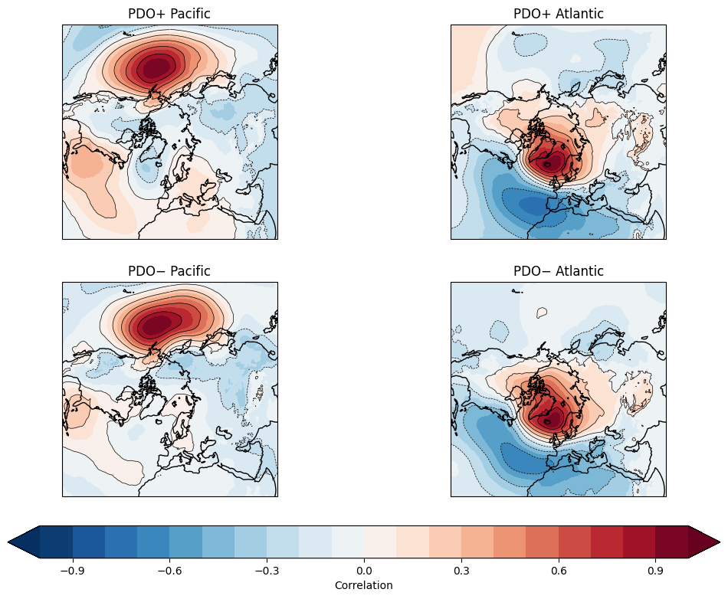
Figure 1:
b.
a.
MSLP Correlation Maps over the Northern Hemisphere associated with Pacific (44°N, 168°W ) and Atlantic (67°N, 9°W) centers during PDO+ and PDO- regimes.
c...
d....

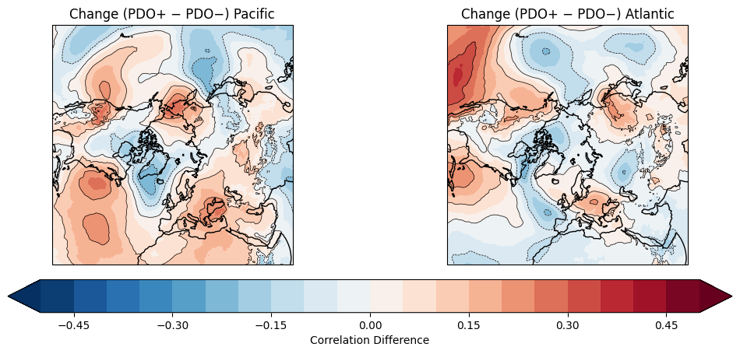
b.
a.
Figure 2:
Change in correlation with each pressure center between PDO regimes

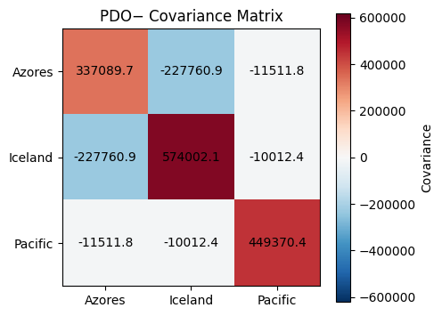
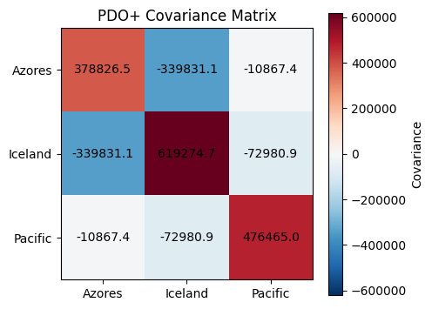
Figure 3:
b.
a.
Covariance matrices between Azore (42°N, 15°W), Iceland (67°N, 9°), and Pacific (44°N, 168°W) centers during PDO+ and PDO- regimes. Covariance units in Pa.

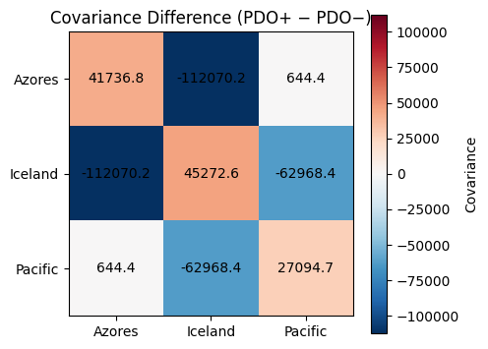
Figure 4:
Change in covariance between PDO regimes. Deeper shaded areas represent covariance amplification by PDO+.

Positive PDO |  |  |  |  | Negative PDO
EOF # | Az. | Ic. | Pac. | Var. | EOF # | Az. | Ic. | Pac. | Var.
1 | -0.56 | 0.81 | -0.14 | 0.59 | 1 | -0.52 | 0.85 | -0.01 | 0.52
2 | -0.20 | 0.03 | 0.98 | 0.32 | 2 | -0.06 | -0.02 | 1.00 | 0.33
3 | 0.80 | 0.58 | 0.15 | 0.09 | 3 | -0.85 | -0.52 | -0.06 | 0.15
Table 1:
Principal component analysis of PDO+ and PDO- regimes over the Azore, Iceland, and Pacific Centers of action. Each row represents the weight of each center on its respective component.

REFERENCES
Ambaum, M. H. P., B. J. Hoskins, and D. B. Stephenson, 2001: Arctic Oscillation or North Atlantic Oscillation?. J. Climate, 14, 3495–3507,
https://doi.org/10.1175/1520-0442(2001)014<3495:AOONAO>2.0.CO;2.
Christiansen, B., On the physical nature of the Arctic Oscillation, Geophys. Res. Lett., 29(16), doi:10.1029/2002GL015208, 2002.
Dai, P., and B. Tan, 2017: The Nature of the Arctic Oscillation and Diversity of the Extreme Surface Weather Anomalies It Generates. J. Climate, 30, 5563–5584, https://doi.org/10.1175/JCLI-D-16-0467.1.
Deser, C. (2000), On the teleconnectivity of the “Arctic Oscillation”, Geophys. Res. Lett., 27(6), 779–782, doi:10.1029/1999GL010945.
Feldstein, S. B., and C. Franzke, 2006: Are the North Atlantic Oscillation and the Northern Annular Mode Distinguishable?. J. Atmos. Sci., 63, 2915–2930, https://doi.org/10.1175/JAS3798.1.
Gong, H., L. Wang, W. Chen, and D. Nath, 2018: Multidecadal Fluctuation of the Wintertime Arctic Oscillation Pattern and Its Implication. J. Climate, 31, 5595–5608, https://doi.org/10.1175/JCLI-D-17-0530.1.
Hu, S., Zhang, W., Jiang, F. et al. Understanding the sub-seasonal variation in the wintertime AO spatial pattern from the viewpoint of El Niño-Southern Oscillation. Clim Dyn 60, 3629–3643 (2023). https://doi.org/10.1007/s00382-022-06533-5
Itoh, H., 2008: Reconsideration of the True versus Apparent Arctic Oscillation. J. Climate, 21, 2047–2062, https://doi.org/10.1175/2007JCLI2167.1.
Jolliffe, I. T., 1986: Principal Component Analysis. Springer-Verlag, 290 pp.
Mantua, N. J., S. R. Hare, Y. Zhang, J. M. Wallace, and R. C. Francis, 1997: A Pacific Interdecadal Climate Oscillation with Impacts on Salmon Production*. Bull. Amer. Meteor. Soc., 78, 1069–1080, https://doi.org/10.1175/1520-0477(1997)078<1069:APICOW>2.0.CO;2.
Newman, M., and Coauthors, 2016: The Pacific Decadal Oscillation, Revisited. J. Climate, 29, 4399–4427, https://doi.org/10.1175/JCLI-D-15-0508.1.
Thompson, D. W. J., and J. M. Wallace, 1998: The Arctic oscillation signature in wintertime geopotential height and temperature fields. Geophys. Res. Lett, 25 , 1297–1300. https://doi.org/10.1029/98GL00950
Thompson, D. W. J., and J. M. Wallace, 2000: Annular Modes in the Extratropical Circulation. Part I: Month-to-Month Variability. J. Climate, 13, 1000–1016, https://doi.org/10.1175/1520-0442(2000)013<1000:AMITEC>2.0.CO;2.
Thompson, D. W. J., J. M. Wallace, and G. C. Hegerl, 2000: Annular Modes in the Extratropical Circulation. Part II: Trends. J. Climate, 13, 1018–1036, https://doi.org/10.1175/1520-0442(2000)013<1018:AMITEC>2.0.CO;2.
Walker, G. T., and E. W. Bliss, 1932: World weather V. Mem. Roy. Meteor. Soc, 4 , 53–84
Wallace, J.M. (2000), North atlantic oscillatiodannular mode: Two paradigms—one phenomenon. Q.J.R. Meteorol. Soc., 126: 791-805. https://doi.org/10.1002/qj.49712656402
Wallace, J. M., and D. S. Gutzler, 1981: Teleconnections in the Geopotential Height Field during the Northern Hemisphere Winter. Mon. Wea. Rev., 109, 784–812, https://doi.org/10.1175/1520-0493(1981)109<0784:TITGHF>2.0.CO;2.

